**Bug Report**

Deleteing all text while editing todo item does not delete the todo entity.

**Submitter**

dcronin

**Date Seen**

12/17/16

**Versions**

Window 7

Chrome 55.0.2883.87 m (64-bit)

<http://todomvc.com/examples/angular2/>

**Bug Description**

Changing an todo item to blank string does not delete the item as desired. Instead an empty entity remains and the placement of the delete icon moves on top of another todo item.

**Severity**

Minor

**Steps to Reproduce**

1. Load url the http://todomvc.com/examples/angular2/ into a chrome browser.
2. Create a todo list of three items by entering strings into the entry field and hitting enter.
3. Double click on the second or middle item to edit it.
4. Highlight all text in the editing field.
5. Delete the highlighted text.
6. Click on the spot where the check circle used to be.

**Actual Behavior**

Once the mouse is clicked the todo entity is not deleted. The size of the entity is shrunk and the placement of the delete icon overlaps onto another todo item.

**Expected Behavior**

Once the Enter key is hit the todo entity is deleted and the rest of the todo items slide up to fill it’s place.

**Workaround**

Click the delete icon after the text is replaced with a blank string.

**Screenshots**

Before:

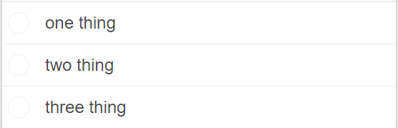

During:

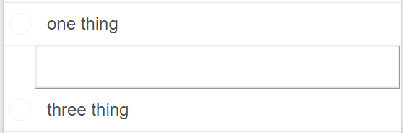

After:

